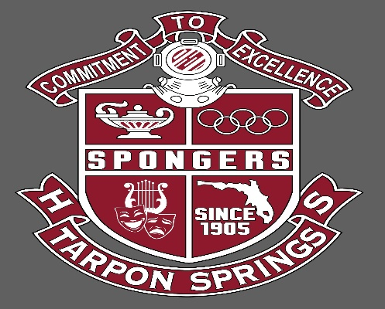 Tarpon Springs High School “Home of the Spongers”
School Improvement Plan Executive Summary August 2022

Principal: Mrs. Leza Fatolitis
Assistant Principals: Mr. Martin Guevara Guidance Counselors: Mrs. Alyssa Cerge
Mrs. Lisa Lennox Mrs. Irene Pantelis
Mr. Michael Mellinger Mrs. Sharon Savino

Vision: 100% Student Success

Mission: To prepare every student to be a productive citizen and provide them with the skill set necessary to be successful in life.

2022 – 2023 School Improvement Goals
- Integrate the systemic use of Professional Learning Communities to assist with collaboration among staff, review student achievement data and revise instructional delivery to promote student success.
- Continue to incorporate the use of AVID WICOR strategies school wide.
- Implement a positive behavior incentive system for all TSHS students and reward, recognize and celebrate students.
- Focus efforts on closing the achievement gap for students in English and Math (Algebra)
- Increase opportunities for students to participate in extra-curricular and co-curricular events
- Increase rigor in core content while incorporating the use of literacy in all subjects/courses on campus.
- Continue to maintain a safe, engaging campus focusing on high yield systems that promote positive school culture and spirit.
- Increase percentage of students seeking college credit, industry certification and program participation.
- Improve community connections, mentorship and student/staff support which will have a direct impact school’s productivity and performance.

Points of Pride
- Substantial student learning gains in English Language Arts for grades 9 and 10 as measured by the 2022 Florida Standards Assessment
- 84 percent of the Tarpon Springs High School Class of 2022 earned an accelerated component (industry certification or college credit)
- Approximately 80 percent of the TSHS students are scheduled in a 4-year program pathway.
- Our graduation rate is 98 percent which is the highest in the school’s history.
- Expansion the AVID program where school wide systems are in place
- Expansion of Cambridge AICE program over the last 5 years
- The Jacobson Culinary Arts Academy maintains a National certification and students who complete the program have opportunity to earn this distinction as well as participate in Dual Enrollment with an articulation with Pinellas Technical College
- The Veterinary Science Academy is recognized as an Academy of Distinction. In our academy is one of the few traditional high schools within the country to have a synthetic cadaver dog for experiential learning manufactured by Syndaver Labs in Tampa, FL.
- 19-million-dollar major campus renovation including new state-of the-art facilities for the Leadership Conservatory for the Arts completed in 2019
- TSHS band continues to be invited to perform and compete on national stages including the Macy’s Thanksgiving Day Parade, Essentially Ellington at Lincoln Center and Bands of America. The program consistently ranks in the top five both regionally and nationally by competing in Bands for All circuit.

Action Steps
- Increase positive school culture to close the achievement gap between student subgroups – black/non-black
- Increase equity centered professional development, focusing on launching a study on Equitable Grading practices
- Increase graduation rate from 98% to 100%
- Increase College and Career Readiness rate from 85% to 90%
- Increase ELA proficiency rate from 52% to 62%
- Increase Algebra proficiency rate from 14% to 30%
- Increase Geometry proficiency rate from 50% to 60%
- Increase US History proficiency rate from 62% to 75%
- Increase Biology proficiency rate from 63% to 73%
- Increase proficiency rate for the Students with Disabilities subgroup – ESSA data from 39% to 50% on the Federal Index
- Increase parent involvement by:
  - increasing frequency of parent workshops for families of all grades
  - hosting Coffee and Conversations with Mrs. Fatolitis where families can share ideas, ask questions and talk about school goals and supports
  - distribute quarterly parent/student stakeholder surveys
  - implementing a school wide – “Adopt-a-Class” program
- Increase community engagement by semi-annually presented at the TS City of Commission meetings, quarterly updates shared in local newspaper, increasing social media footprint via the school’s (Twitter and Facebook) accounts
- Reduce the number of student absences (who missed 10%+) by 10%.
- Reduce the number of student arrests on campus by 50%

